|  |
| --- |
| System Design |
| Major Project – CS39440 |
| Version 1.0 |
|  |

|  |
| --- |
| Robert Mouncer (rdm10@aber.ac.uk)  Software Engineering MEng - G601  Supervisor – Neal Snooke (nns@aber.ac.uk) |
|  |

Introduction

This document will give an overall system design for the air quality mapping project. It will not get into detail of each system but rather show the overall structure. This document should be read alongside the two other design documents:

* Monitoring Design
* Visualization Design

The project is split into two systems the monitoring and visualisation. The monitoring will take readings using a Raspberry Pi microcontroller and upload data to a server. The visualisation system will create heat/contour maps using the data collected from the raspberry pi.

# Overall System

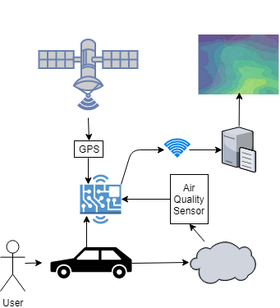

The aim is to use a microcontroller with a GPS and microcontroller to take readings within a vehicle to detect air quality on public roads. The GPS will take readings and match them with an air quality reading. These values will be uploaded to Aberystwyth university MySQL server to be used with the visualisation application. The data will be uploaded when connected to a known network which the microcontroller will connect to automatically.

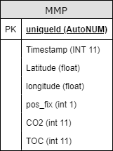

The MySQL server will use one table to store the data so it does not need normalising, the data will be very limited and only hold what is necessary. The server is the connection between the two systems.